EXPERIMENT NO. 08
CREATING CONTAINERIZED APPLICATIONS WITH DOCKER
AND EXPLORING DOCKER HUB

1. Aim
To study Docker containerization, create and run a simple containerized web application, and explore Docker Hub as a registry for sharing container images.

2. Objectives
- Understand containers, images, Docker Engine, Dockerfile, and registries.
- Create a small web application and package it into a Docker image.
- Build, run, inspect, and stop a container using Docker CLI commands.
- Explore Docker Hub, pull a public image, and understand image tagging and publishing.
- Identify basic security and cleanup practices.

3. Theory

3.1 What is Docker?
Docker is a platform and toolset for building, distributing, and running applications in containers. A container packages an application with its runtime dependencies and configuration so it can run consistently across supported environments. Containers share the host operating-system kernel, so they are generally lighter than full virtual machines, which each require a separate guest operating system.

3.2 Containers and images
A Docker image is a read-only template containing the application and the files needed to run it. A container is a runnable instance of an image. Multiple containers can be created from the same image. A container's writable layer is normally temporary; persistent application data should be stored in volumes or external services.

3.3 Dockerfile
A Dockerfile is a text file containing instructions used to build an image. Common instructions include FROM (base image), WORKDIR (working directory), COPY (copy files), RUN (execute build commands), EXPOSE (document a port), and CMD (default command).

3.4 Docker Hub
Docker Hub is a hosted container image registry. It lets users find public images, store and share images in repositories, and pull images to their own machines. Repositories may be public or private depending on account and plan. Before using an image, check its publisher, documentation, update history, and security information.

3.5 Architecture
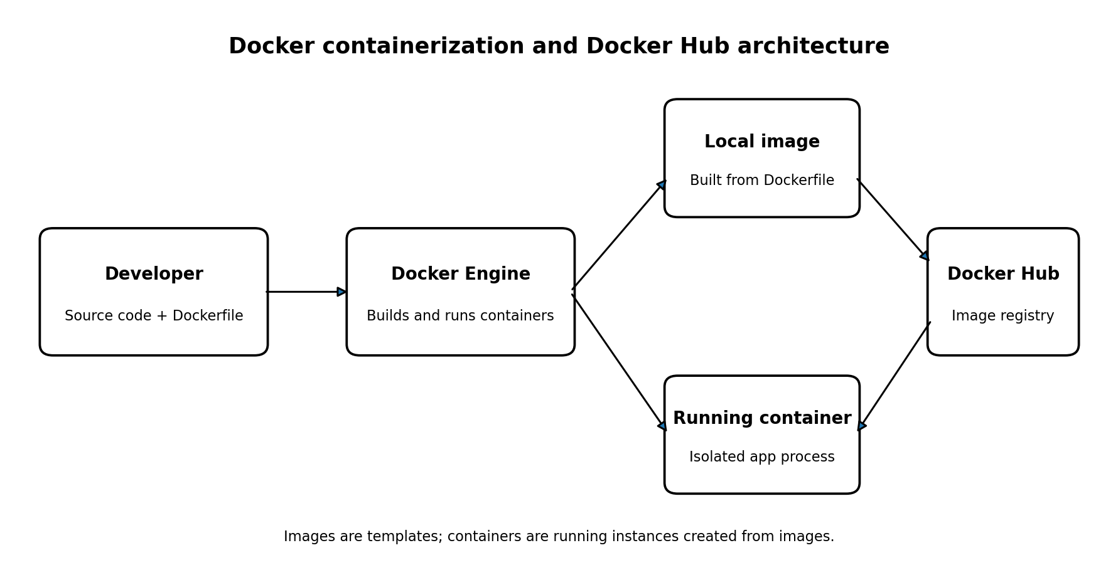
Figure 1: Conceptual flow between source code, Docker Engine, images, containers, and Docker Hub.

4. Requirements
- Computer with Windows, macOS, or Linux and sufficient permissions to run Docker.
- Docker Desktop or Docker Engine with Docker CLI installed and running.
- Text editor for creating application files and a Dockerfile.
- Internet connection for pulling base images and exploring Docker Hub.
- A Docker Hub account only if you want to push an image to your own repository.
Note: Commands may differ slightly by operating system or Docker installation. Do not publish secrets, API keys, private code, or confidential data in an image.

5. Practical implementation

5.1 Create a project folder
Create a folder named docker-web-demo and create the following two files inside it.

File 1: index.html
<!doctype html>
<html lang="en">
<head>
<meta charset="utf-8">
<meta name="viewport" content="width=device-width, initial-scale=1">
<title>Docker Demo</title>
</head>
<body>
<h1>Hello from a Docker container!</h1>
<p>This web page is served by a containerized application.</p>
</body>
</html>

File 2: Dockerfile
FROM nginx:alpine
COPY index.html /usr/share/nginx/html/index.html
EXPOSE 80
CMD ["nginx", "-g", "daemon off;"]
This example uses the Nginx web server image and copies the custom page into its default web directory.

5.2 Build the Docker image
cd docker-web-demo
docker build -t docker-web-demo:1.0 .
The command builds an image from the Dockerfile in the current directory and tags it docker-web-demo:1.0. The final dot specifies the build context.

5.3 Run the container
docker run -d --name docker-web-container -p 8080:80 docker-web-demo:1.0
The -d option runs the container in the background. The -p 8080:80 option maps port 8080 on the host to port 80 inside the container.

5.4 Test the application
Open http://localhost:8080 in a browser. The page should display “Hello from a Docker container!” if the build and port mapping succeeded.
docker ps
docker logs docker-web-container
docker inspect docker-web-container

5.5 Stop and remove the container
docker stop docker-web-container
docker rm docker-web-container
The image remains on the machine unless it is separately removed.

6. Exploring Docker Hub

6.1 Find and pull a public image
Open https://hub.docker.com in a browser and search for an image such as nginx. Review the official publisher, description, available tags, supported architectures, and usage instructions.
docker pull nginx:alpine
docker image ls

6.2 Tag the custom image for Docker Hub
Create a repository in Docker Hub first. Replace YOUR_DOCKERHUB_USERNAME with your actual username and choose a repository name you created.
docker login
docker tag docker-web-demo:1.0 YOUR_DOCKERHUB_USERNAME/docker-web-demo:1.0
docker push YOUR_DOCKERHUB_USERNAME/docker-web-demo:1.0
Docker login may open a browser-based authentication flow. Do not put your password or access token directly into the report or source files. Pushing is optional; it requires a Docker Hub account and permission to publish to the target repository.

6.3 Pull the published image
docker pull YOUR_DOCKERHUB_USERNAME/docker-web-demo:1.0
docker image ls
If the repository is public, another user can pull the image by its full repository name and tag. For a private repository, the user must have access.

7. Useful Docker commands
Command | Purpose
docker --version | Check Docker CLI version
docker images | List local images
docker ps | List running containers
docker ps -a | List all containers, including stopped ones
docker build -t name:tag . | Build and tag an image
docker run -d -p 8080:80 image:tag | Run a container with port mapping
docker logs container-name | Display container logs
docker stop container-name | Stop a running container
docker rm container-name | Remove a stopped container
docker rmi image:tag | Remove a local image if no longer needed
docker pull image:tag | Download an image from a registry
docker push user/repo:tag | Upload an image to a registry

8. Experiment workflow
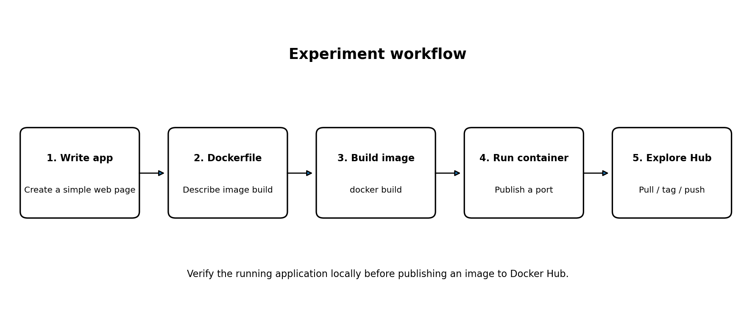
Figure 2: Workflow for building, running, verifying, and publishing a container image.

9. Observations and expected output
Step | Expected observation
docker build | Build completes and image docker-web-demo:1.0 appears in local image list.
docker run | Docker returns a container ID and the container appears in docker ps.
Browser test | http://localhost:8080 displays the custom HTML page.
docker logs | Logs show Nginx startup or access information, depending on timing.
docker pull nginx:alpine | The Nginx image is downloaded or reported as already present.
docker push (optional) | Image layers upload and the tagged image appears in the Docker Hub repository.
Record the actual output from your own machine. These are expected observations, not claimed screenshots or execution results.

10. Advantages of Docker
- Consistent application packaging across development and deployment environments.
- Fast startup and lower overhead than running a full virtual machine for many workloads.
- Portability through image registries.
- Repeatable builds and simplified deployment workflows.
- Isolation between application processes and their dependencies.

11. Security and best practices
- Use trusted, maintained base images and pin versions appropriately for reproducible builds.
- Avoid embedding passwords, tokens, private keys, or other secrets in Dockerfiles or images.
- Run containers with only the permissions they need; avoid privileged mode unless essential.
- Keep images small and rebuild them to incorporate security updates.
- Expose only required ports and avoid publishing administrative services unnecessarily.
- Use volumes or managed storage for data that must persist beyond a container's lifecycle.
- Review image provenance and scan images for known vulnerabilities where tooling is available.

12. Result
The experiment procedure demonstrates how to create a simple web application, package it as a Docker image, run it in a container, test it through a mapped host port, and explore pulling and publishing images through Docker Hub. The experiment is complete after the local browser test succeeds and the relevant command outputs are recorded. Publishing to Docker Hub is an optional extension.

13. Conclusion
Docker makes it possible to package an application and its dependencies into a portable image and run it as a container. Docker Hub provides a convenient registry for discovering, pulling, and sharing container images. The experiment illustrates the basic image-build-run-publish workflow and highlights the importance of image trust, secret handling, port configuration, and cleanup.

14. Viva questions
What is Docker? A platform for building, distributing, and running applications in containers.
What is the difference between an image and a container? An image is a template; a container is a running or stopped instance created from an image.
What is a Dockerfile? A text file containing instructions for building a Docker image.
What is Docker Hub? A hosted registry for discovering and sharing container images.
What does docker build do? Builds an image from a build context and Dockerfile.
What does -p 8080:80 mean? It maps host port 8080 to container port 80.
Why should secrets not be added to an image? Image layers can preserve them and they may be exposed to anyone who can access the image.
How can a container be stopped? Use docker stop followed by the container name or ID.

15. References
- Docker Docs, Get started: https://docs.docker.com/get-started/
- Docker Docs, Dockerfile reference: https://docs.docker.com/reference/dockerfile/
- Docker Docs, Docker Hub: https://docs.docker.com/docker-hub/
- Docker Hub: https://hub.docker.com/

